caXchange Logging and Auditing using Common Logging Module
Design Document

Version No: 0.1
Last Modified: 10/11/2007

Author : Kalpesh S. Patel
Team : caXchange

Client : National Cancer Institute - Center for Bioinformatics,
National Institutes of Health,
US Department of Health and Human Services

Document History

Document Location
The most current version of this document is located in CVS.

Revision History
Version Number | Revision Date | Author | Summary of Changes
0.1 | 10/15/07 | Kalpesh S. Patel | Initial draft

Review
Name | Team/Role | Version | Date Reviewed | Reviewer Comments

Related Documents
More information can be found in the following related documents:
Document Name
caCORE 3.2_Tech_Guide (Chapter 10: Common Logging Module)
CSM – User Provisioning Tool User Guide (ftp://ftp1.nci.nih.gov/pub/cacore/CSM/UPT_User_Guide.pdf)

Table of Contents
1. Introduction 4
1.1 Purpose 4
1.2 Scope 4
2. Requirements 4
2.1 Trace the flow of a message through caXchange. 4
2.2 User should be able to filter messages to log. 4
3. Component View 5
4. Logical design 6
4.1 Sequence Diagram 7
5. Data 9
6. Deployment 9
6.1 Sample servicemix.xml configuration 9
7. Test Cases and Scenarios 10

Introduction

The caXchange is defined as the software component that is primarily responsible for receiving input from various external systems, routing the input to various services that are hosted on the hub, and eventually routing the output of those services to external systems. Common Logging Module (CLM) provides the audit and logging services under caCORE set of tools. It includes a set of tools such as the log-locator web application. Integrating CLM with caXchange for logging enables the use of these tools for caXchange logs.

Purpose
The purpose of this document is to document the design of integration between caXchange and Common Logging Module.

Scope
The scope of this document is limited to the integration between caXchange and Common Logging Module.

Requirements

Trace the flow of a message through caXchange.
The user should be able to see the how a message was processed through caXchange.

User should be able to filter messages to log.
The user should have the ability to filter the messages they want to log.

Component View
Figure 3-1
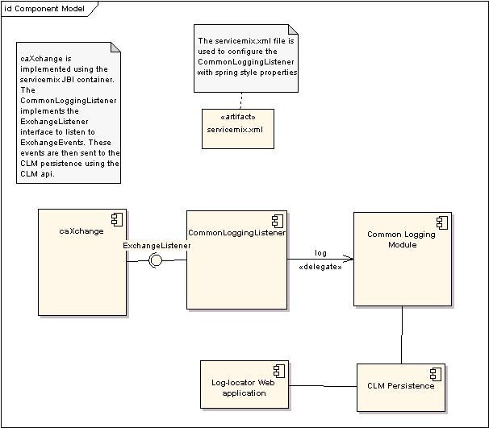

- CommonLoggingListener registers with the caXchange Servicemix JBI Container to listen for all ExchangeEvents
- Servicemix JBI Container sends ExchangeEvents all registered ExchangeListeners ExchangeEvents.
- CommonLoggingListener logs the exchange events using the Common Logging Module.
- CommonLoggingListener can be configured using servicemix.xml with spring style configuration.

Logical design
The integration between CLM and caXchange can be achieved by implementing the ExchangeListener interface. The CommonLoggingListener implements this interface. Additionally it adds properties to enable logging of messages meeting certain criteria. Each method of the ExchangeListener can be disabled using spring configuration in servicemix.xml. Additional String filters can be specified in this file, so that only messages matching those filters are logged.
The ExchangeListener interface has the following operations.

Operations

Method | Notes | Parameters
public void exchangeSent(exchangeEvent), | Exchange listener interface. Receives messages from NMR before an exchange is sent. | ExchangeEvent exchangeEvent
public void exchangeAccpeted(exchangeEvent), | Exchange listener interface. Receives messages from NMR after an exchange is accepted. | ExchangeEvent exchangeEvent

Fig 4.1

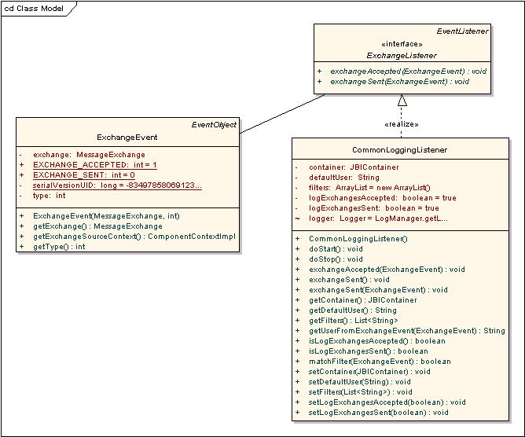

Sequence Diagram

Successful Scenario of the sequence of the flow is depicted below:

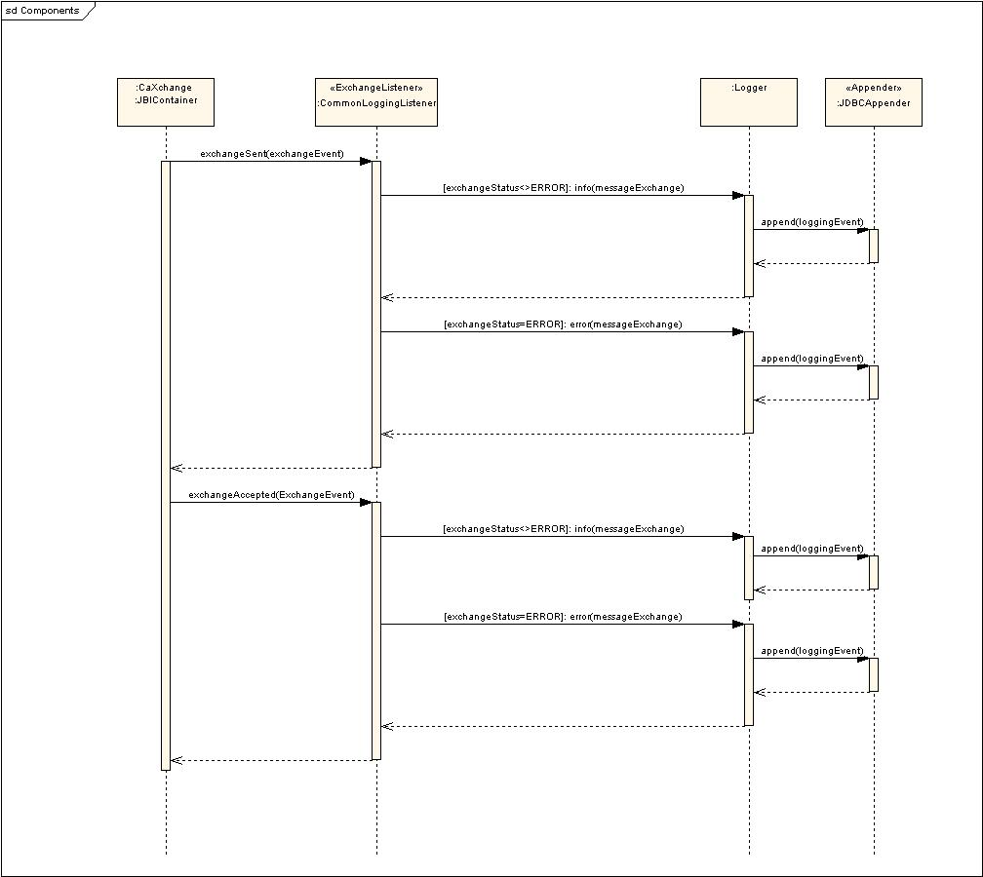

Data

Database schema would be created to facilitate logging and auditing for caXchange. Please refer to CLM LLT deployment Guide for more details.

Deployment
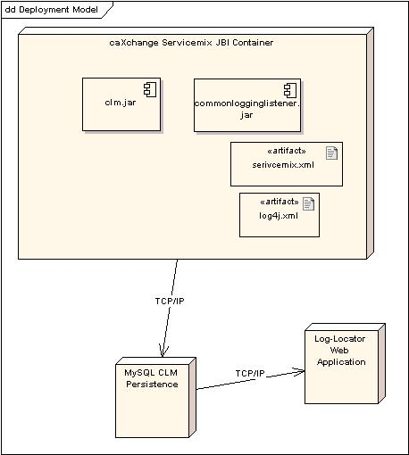

Sample servicemix.xml configuration
<bean id="CLMLogger" class="gov.nih.nci.caxchange.servicemix.jbi.audit.CommonLoggingListener" init-method="doStart" >
<property name="container" ref="jbi" />
<property name="logExchangesSent" value="true" />
<property name="logExchangesAccepted" value="false" />
<property name="filters">
<list>
<value>Match</value>
</list>
</property>
</bean>

Test Cases and Scenarios
Please refer to the caXchangeTesting Approach Document for test cases.

